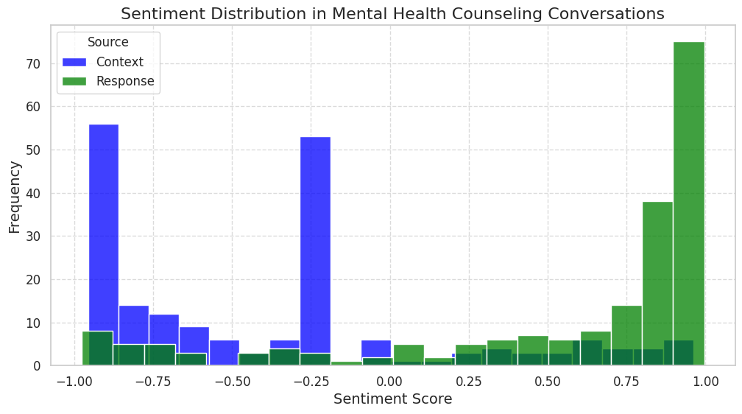

**Slide Title: Sentiment Distribution in Mental Health Counseling Conversations**

**Description:**

This histogram visualizes the distribution of sentiment scores for both user inputs (**Context**) and counselor responses (**Response**) in mental health counseling conversations. The sentiment scores range from -1 (strongly negative) to 1 (strongly positive), with 0 indicating a neutral sentiment.

* **Blue Bars** : Represent the frequency of different sentiment scores in user inputs (**Context**). Users often express negative emotions when seeking help, as shown by the higher frequency of sentiment scores around -0.5 to -1.
* **Green Bars** : Represent the frequency of different sentiment scores in counselor responses (**Response**). Counselors tend to provide supportive and positive advice, as indicated by the higher frequency of positive sentiment scores (around 0.5 to 1).

**Key Observations:**

* Users frequently express negative sentiments, reflecting their emotional state when seeking assistance.
* Counselors consistently respond with positive and supportive messages, helping to alleviate users' negative emotions.
* The difference in sentiment distributions between **Context** and **Response** highlights the role of counselors in transforming negative emotions into more positive ones.

**Implications:**

* Understanding these sentiment patterns is crucial for designing effective chatbots and training counselors to handle various emotional states.
* The data can be used to develop targeted interventions and support strategies for users experiencing mental health challenges.

By analyzing the sentiment distribution, we gain valuable insights into the emotional dynamics of mental health counseling conversations, which can inform the development of more empathetic and effective support systems.

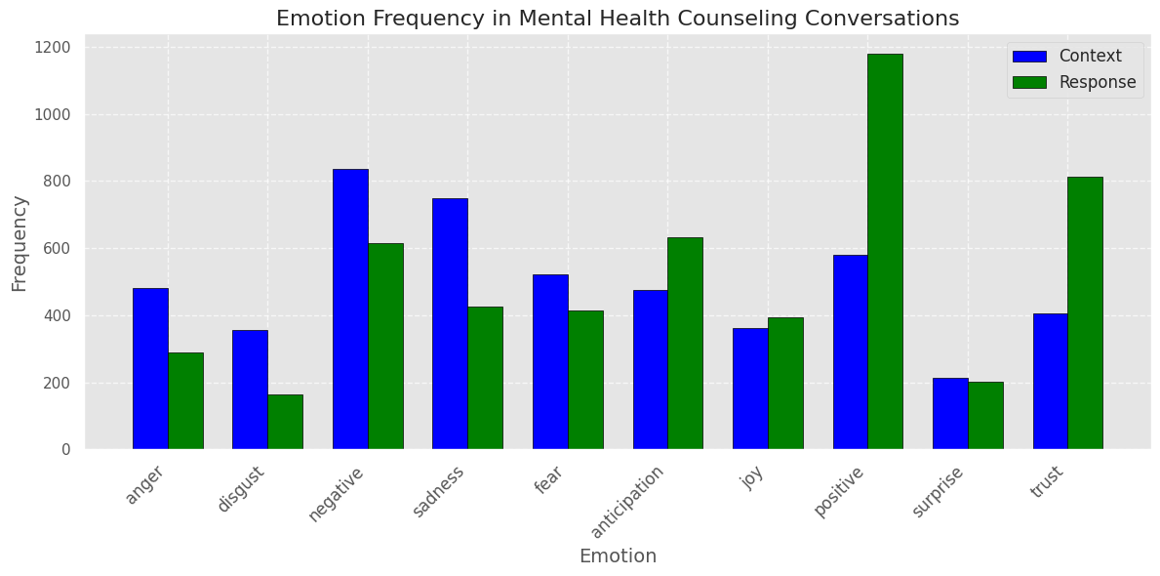

**Slide Title: Emotion Frequency in Mental Health Counseling Conversations**

**Description:**

This combined bar chart illustrates the frequency of different emotions expressed in both user inputs (**Context**) and counselor responses (**Response**) within mental health counseling conversations.

* **Blue Bars** : Represent the frequency of various emotions in user inputs (**Context**). The chart shows that users frequently express negative emotions such as **negative** and **sadness**, which are among the most common. Other notable emotions include **anger**, **fear**, and **disgust**.
* **Green Bars** : Represent the frequency of various emotions in counselor responses (**Response**). Counselors tend to use more positive and supportive language, as indicated by higher frequencies of **positive** and **trust**. They also address negative emotions like **sadness** and **fear** with empathy and reassurance.

**Key Observations:**

* Users often express strong negative emotions when seeking help, reflecting their emotional state.
* Counselors respond with a mix of positive reinforcement and empathetic acknowledgment of negative emotions.
* The contrast between the two sets of bars highlights how counselors work to shift the emotional tone from negative to positive.

**Implications:**

* Understanding the emotional landscape of user inputs helps in tailoring support strategies and interventions.
* Counselors' ability to address negative emotions with positive and supportive responses is crucial for effective counseling.
* This analysis can inform the development of chatbots and training programs for counselors to better handle various emotional states.

By analyzing the frequency of emotions in both user inputs and counselor responses, we gain valuable insights into the emotional dynamics of mental health counseling conversations, which can be used to improve support systems and counseling practices.

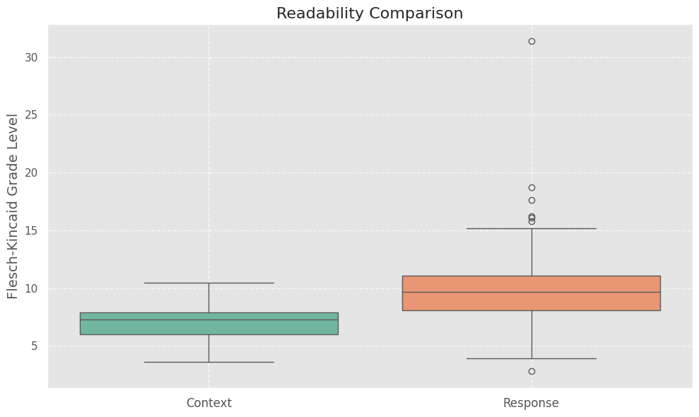

**Slide Title: Readability Comparison in Mental Health Counseling Conversations**

**Description:**

This box plot compares the readability scores of user inputs (**Context**) and counselor responses (**Response**) using the Flesch-Kincaid Grade Level metric.

* **Box Plot Components** :
  + The central line in each box represents the median readability score.
  + The box itself represents the interquartile range (IQR), which contains the middle 50% of the data.
  + The whiskers extend to show the range of the data, excluding outliers.
  + Any points outside the whiskers are considered outliers.

**Key Observations:**

* The median readability score of **Response** is generally lower than that of **Context**, indicating that counselors use simpler language to ensure users understand their advice.
* There is less variability in the readability scores of **Response** compared to **Context**, suggesting that counselors maintain a consistent level of simplicity in their responses.
* Outliers in the data may indicate instances where the readability score is significantly different from the rest of the data.

**Implications:**

* Understanding the readability of user inputs and counselor responses helps in tailoring support strategies and interventions.
* Counselors' ability to adjust their language to match the user's reading level is crucial for effective communication.
* This analysis can inform the development of chatbots and training programs for counselors to better handle various reading levels.

By analyzing the readability scores, we gain valuable insights into the language complexity of mental health counseling conversations, which can be used to improve support systems and counseling practices.

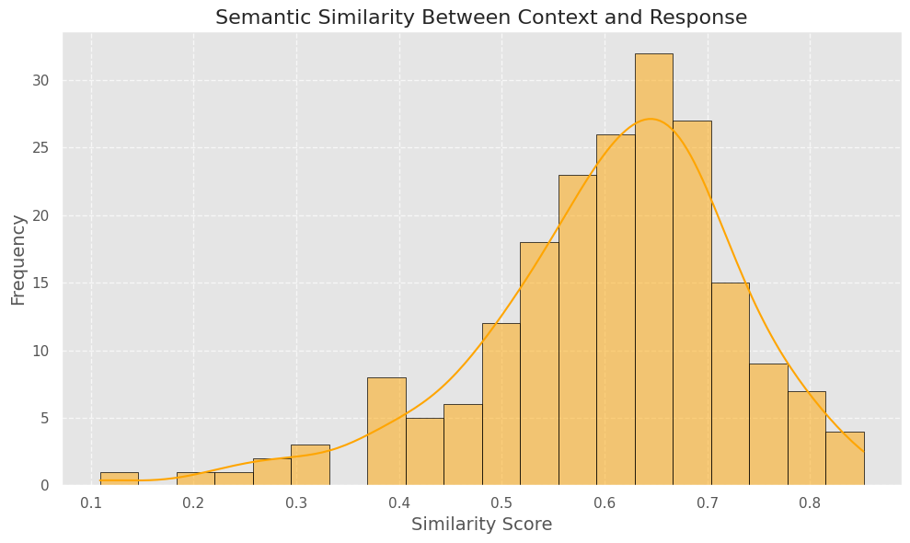

**Slide Title: Semantic Similarity Between Context and Response**

**Description:**

This histogram visualizes the distribution of semantic similarity scores between user inputs (**Context**) and counselor responses (**Response**).

* **Histogram Components** :
  + The x-axis represents the similarity score, ranging from 0 (no similarity) to 1 (perfect similarity).
  + The y-axis represents the frequency of each similarity score.
  + The KDE (Kernel Density Estimate) line provides a smooth curve representing the underlying distribution of the data.

**Key Observations:**

* The majority of similarity scores are clustered around higher values, indicating that counselor responses are generally well-aligned with user inputs.
* There are a few lower similarity scores, which may indicate cases where the response does not fully address the user's concern.
* The KDE line helps visualize the overall shape of the distribution, showing any skewness or multiple peaks.

**Implications:**

* Understanding the semantic similarity between user inputs and counselor responses helps in evaluating the effectiveness of the counseling process.
* High similarity scores suggest that counselors are providing relevant and contextually appropriate responses.
* Low similarity scores may indicate areas for improvement, such as better understanding of user concerns or more tailored responses.

By analyzing the semantic similarity scores, we gain valuable insights into the alignment between user inputs and counselor responses, which can be used to improve support systems and counseling practices.